# Mukul Aggarwal ( 2401030239)

## Problem 1)

class Greeting{

public static void main(String args[]){

System.out.println("hi "+ args[0] + " your age is" + Integer.parseInt(args[1]));

}

}

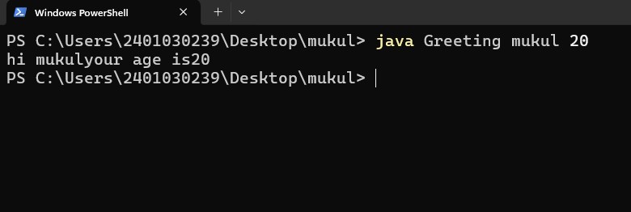

## Problem 2)

class Calculate{

public static void main(String args[]){

int a = Integer.parseInt(args[0]);

int b = Integer.parseInt(args[1]);

System.out.println("parameter is : "+2*(a+b));

System.out.println("area is : "+a*b);

}

}

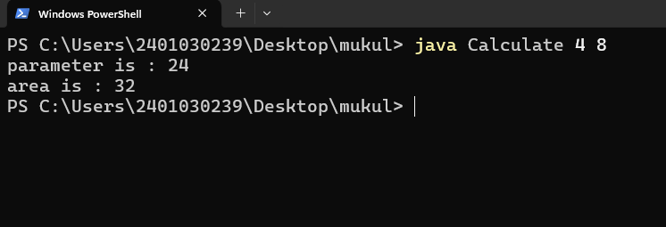

## Problem 1)

class Separate{

public static void main(String args[]){

int odd=0,even=0;

int sum=0;

for(int i=0; i<10; i++){

int a = Integer.parseInt(args[i]);

sum+=a;

if(a%2==1){odd++;}

else{even++;}

}

System.out.println("odd : "+odd+" even : "+even);

System.out.println("and their total sum is : "+sum);

}

}

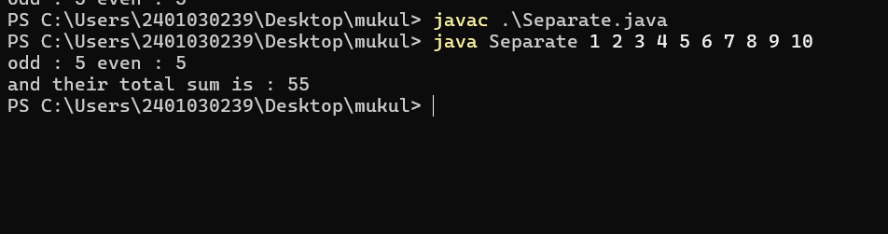

## Problem 2)